**VACCINE PREDICTION**



**TEAM I.D :** **PTID-CDS-APR-24-1887**

**PROJECT I.D :** **PRCP-1014-VACCINE PREDICTION**

**TEAM MEMBERS**

**ANIKET GOSWAMI**

**PRAKASH KUMAR MALLICK**

**NEJUMA M.M**

**SARANYA SEKAR**

**YAYANG SATRIANSYAH**

**INDEX**

|  |  |  |
| --- | --- | --- |
| Sl. No | Title | Page No. |
| 1. | Introduction | 3 |
| 2. | Methodology | 4 |
| 3. | Data Analysis | 5-6 |
| 4. | Data Visualization | 7-10 |
| 5. | Feature Engineering | 11-12 |
| 6. | Model Selection & Training | 13-18 |
| 7. | Discussion | 19 |
| 8. | Conclusion | 20 |
| 9. | Reference | 21 |

**INTRODUCTION**

The introduction sets the stage for exploring the application of predictive modeling across various stages of vaccine development and highlights the potential benefits of integrating these innovative approaches into traditional vaccine research methodologies. Ultimately, the adoption of predictive modeling holds the promise of expediting the development of safe and effective vaccines to combat emerging infectious diseases and address global health challenges.

In this challenge, we will take a look at vaccination, a key public health measure used to fight infectious diseases. Vaccines provide immunization for individuals, and enough immunization in a community can further reduce the spread of diseases through "herd immunity."

As of the launch of this competition, vaccines for the COVID-19 virus are still under development and not yet available. The competition will instead revisit the public health response to a different recent major respiratory disease pandemic. Beginning in spring 2009, a pandemic caused by the H1N1 influenza virus, colloquially named "swine flu," swept across the world. Researchers estimate that in the first year, it was responsible for between [151,000 to 575,000 deaths globally](https://www.cdc.gov/flu/pandemic-resources/2009-h1n1-pandemic.html).

A vaccine for the H1N1 flu virus became publicly available in October 2009. In late 2009 and early 2010, the United States conducted the National 2009 H1N1 Flu Survey. This phone survey asked respondents whether they had received the H1N1 and seasonal flu vaccines, in conjunction with questions about themselves. These -additional questions covered their social, economic, and demographic background, opinions on risks of illness and vaccine effectiveness, and behaviors towards mitigating transmission. A better understanding of how these characteristics are associated with personal vaccination patterns can provide guidance for future public health efforts.

Data is provided courtesy of the United States [National Center for Health Statistics](https://www.cdc.gov/nchs/index.htm).

U.S. Department of Health and Human Services (DHHS). National Center for Health Statistics. The National 2009 H1N1 Flu Survey. Hyattsville, MD: Centers for Disease Control and Prevention, 2012.

Images courtesy of the [U.S. Navy](https://www.flickr.com/photos/navcent/15607260325/) and the [Fort Meade Public Affairs Office](https://www.flickr.com/photos/ftmeade/15242740638/) via Flickr under the [CC BY 2.0 license](https://creativecommons.org/licenses/by/2.0/legalcode).

**METHODLOGY**

**Data Collection:**

1. Gathered vaccine data from reliable sources such as WHO and CDC databases, including information on vaccine candidates, clinical trials, and adverse events.
2. Obtained pathogen data from genomic databases and research publications to understand the biological characteristics of target pathogens.

**Data Preprocessing**:

1. Cleaned the data by removing duplicates and handling missing values to ensure data quality.
2. Conducted feature selection and transformation, including normalization and encoding of categorical variables, to prepare the dataset for analysis.

**Feature Engineering:**

1. Created new features such as time of day, day of the week, and seasonality to capture temporal patterns relevant to vaccine development.
2. Incorporated holidays and other events impacting vaccine distribution and adoption as additional features to improve model accuracy.

**Model Selection**:

1. Chose machine learning models based on task requirements and dataset characteristics, such as logistic regression for binary classification tasks and random forests for handling high-dimensional data.
2. Evaluated ensemble methods like gradient boosting machines for their ability to capture complex relationships and improve predictive accuracy.

**Model Training:**

1. Split the dataset into training and testing sets to assess model performance.
2. Use appropriate metrics such as accuracy, precision, recall, F1-score, and area under the ROC curve (AUC) to evaluate model performance.

**DATA ANALYSIS**

The preprocessing phase involves meticulous cleaning and preparation of the gathered data. Duplicate entries are removed, and missing values are addressed to maintain data integrity. Furthermore, categorical variables are encoded, and numerical data is normalized or standardized to enhance consistency across the dataset. This step ensures that the data is structured and formatted appropriately for subsequent analysis and modeling tasks. By meticulously preparing the data through preprocessing, researchers can mitigate the risk of bias, errors, or inconsistencies, thereby laying a solid foundation for accurate and reliable vaccine prediction models.

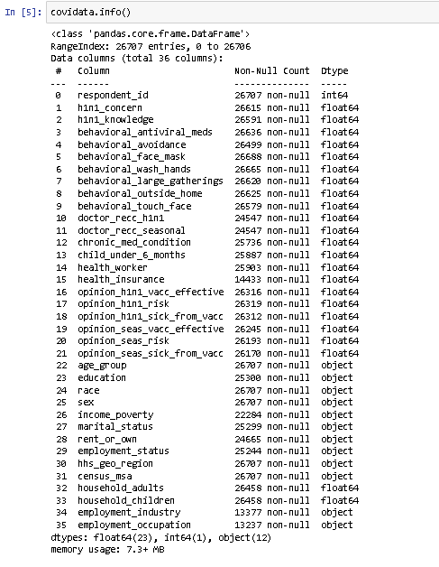

* Replace missing categorical values with mode and numerical values with mean. Use mode for categorical columns and mean for numerical columns.

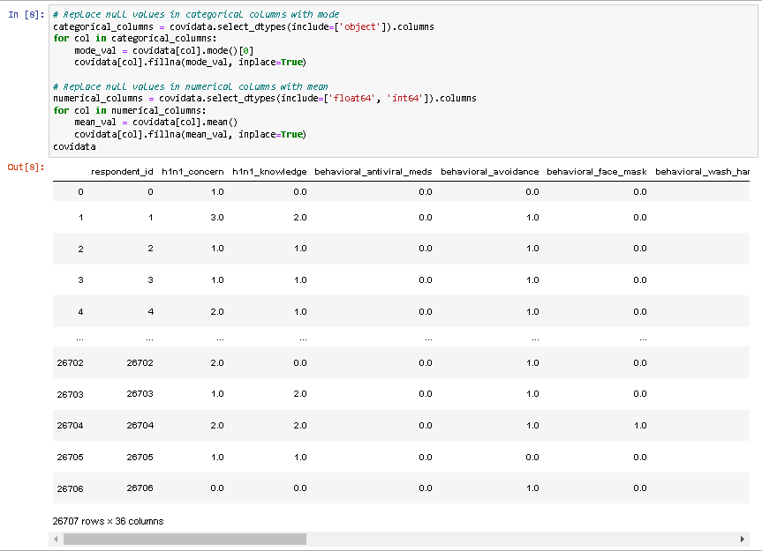

* After replacing missing values with mode for categorical and mean for numerical data, the dataset shows no null values, ensuring completeness for analysis.

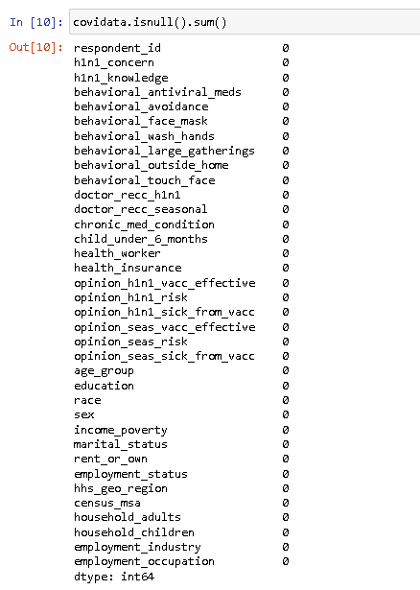

**DATA VISUALIZATION**

Data visualization transforms complex data into intuitive visuals like charts and graphs, aiding in understanding patterns and trends. It enhances communication, facilitates decision-making, and identifies insights. Techniques such as scatter plots and histograms, along with tools like matplotlib and Tableau, create interactive visuals for exploring data dynamically. Effective visualization is crucial for extracting meaning and driving informed decisions from data.

* Merged 'h1n1_vaccine' and 'seasonal_vaccine' into 'Vaccine Type', displayed using countplot. 'Vaccine Status' on y-axis, 'Vaccine Type' on x-axis, and differentiated by hue.

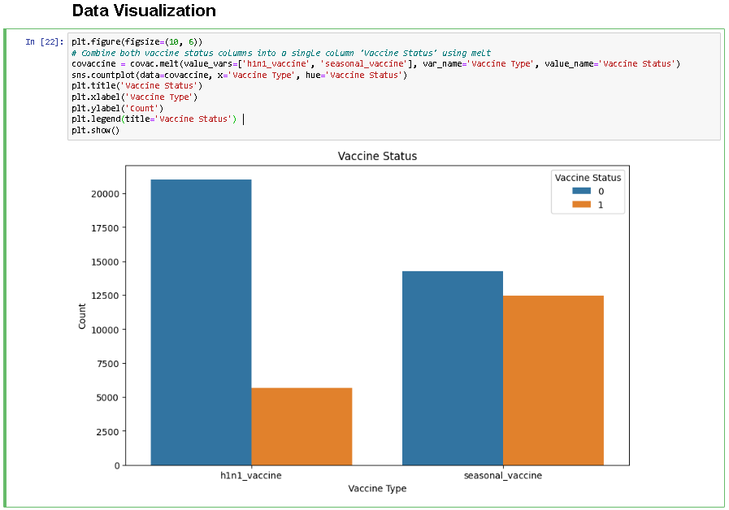

* Visualized H1N1 and seasonal vaccine status by age group using countplot. Separate subplots for each vaccine, with age groups on x-axis and counts on y-axis.

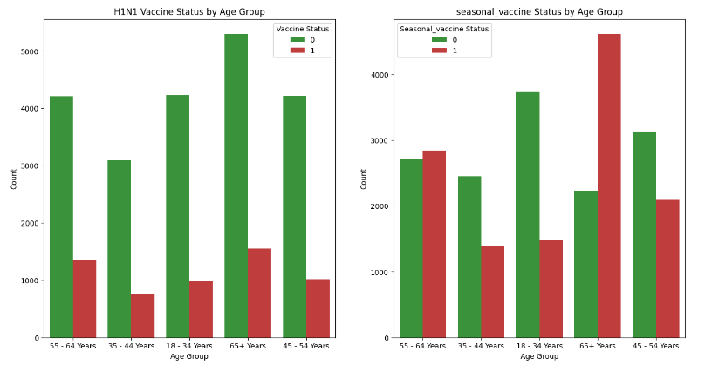

* Plotted H1N1 and seasonal vaccine status by education level using countplot. Subplots display counts for each vaccine, with education levels on the x-axis and counts on the y-axis.

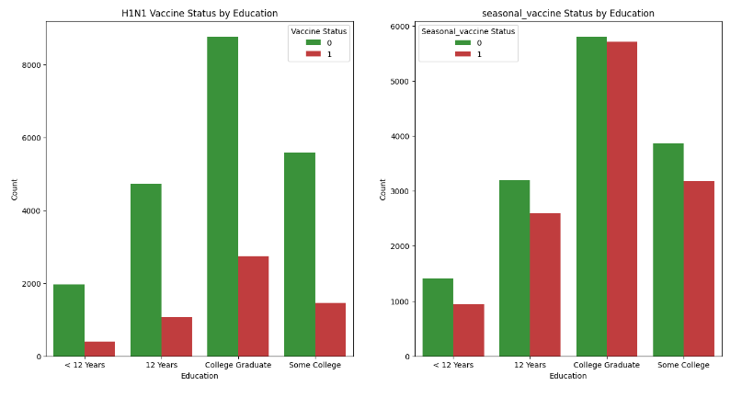

* Visualized H1N1 and seasonal vaccine coverage using pie charts. Each chart displays the distribution of vaccine status, with percentages shown. The legend titles indicate the respective vaccine coverage percentages for H1N1 and seasonal vaccines.

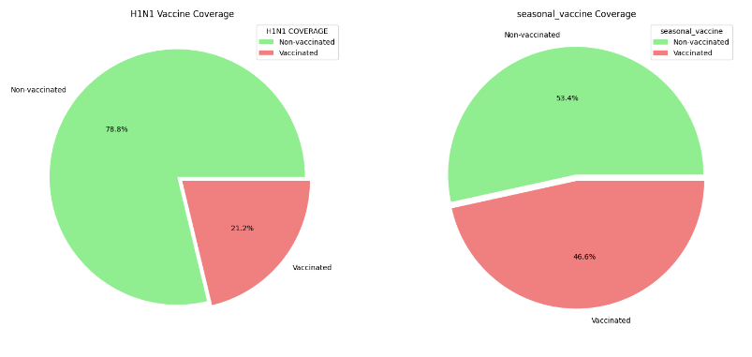

* The script loads vaccination data, counts individuals recommended for H1N1 and seasonal flu vaccines, calculates non-vaccinated counts, and visualizes the distribution with pie charts for both vaccines, highlighting the proportions of vaccinated versus non-vaccinated individuals.

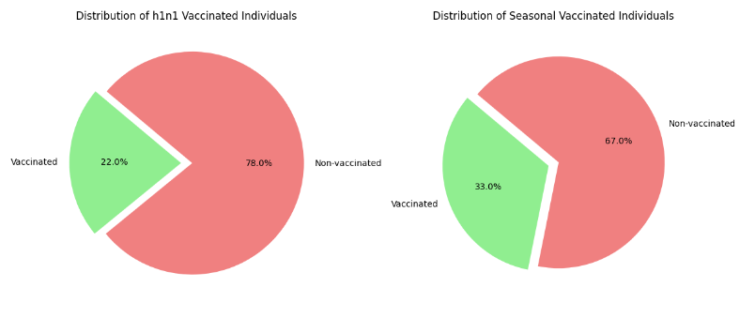

* The script creates bar plots to visualize the relationship between opinions on vaccine effectiveness and actual vaccination rates. Using custom colors, it first plots 'opinion_h1n1_vacc_effective'against 'h1n1_vaccine',then 'opinion_seas_vacc_effective' against 'seasonal_vaccine'. These plots highlight how perceived vaccine effectiveness influences vaccination rates for H1N1 and seasonal flu.

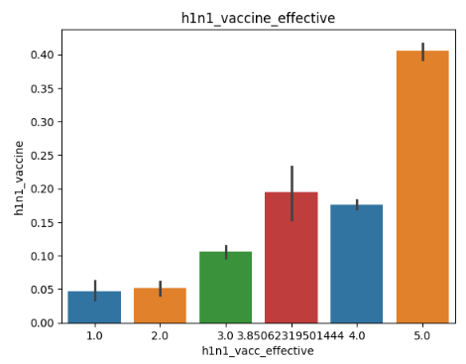 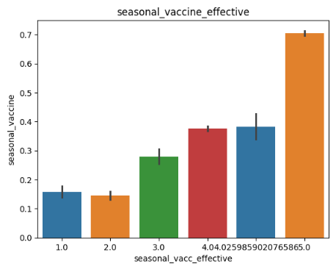

* The script creates new features 'cleanliness' and 'opinion' by summing related behavioral and opinion columns, respectively, from the dataset `covac`. It converts these sums to integers and visualizes the distributions of these new features using count plots, highlighting the aggregated behavioral cleanliness and overall vaccination opinions of individuals.

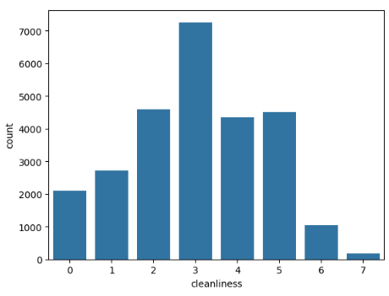 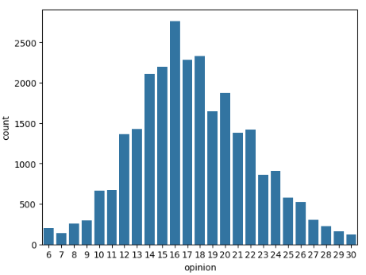

**FEATURE ENGINEERING**

Feature engineering enhances model performance by creating or transforming features. Techniques include interaction terms, variable transformations, categorical encoding, date-time feature generation, and handling missing values. Effective feature engineering improves model interpretability, predictive accuracy, and insights extraction from data, ultimately leading to better decision-making and understanding of underlying patterns and relationships.

* The code utilizes LabelEncoder from sklearn.preprocessing to encode categorical variables in DataFrame 'covac'. It iterates over each column, checks for 'object' dtype, then fits and transforms using LabelEncoder.

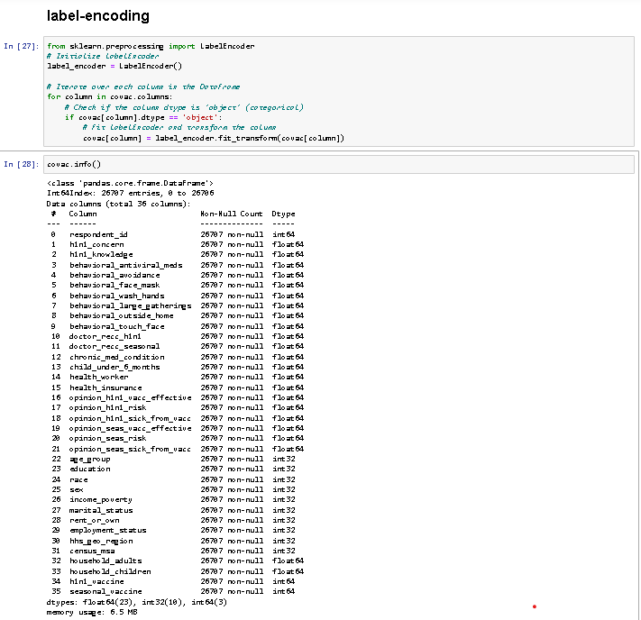

* Displayed correlation heatmap for variables in 'covac' dataset. Heatmap colors represent correlation strength, with positive correlations in green and negative in red. Annotations show correlation coefficients. This visualization aids in identifying relationships between variables.

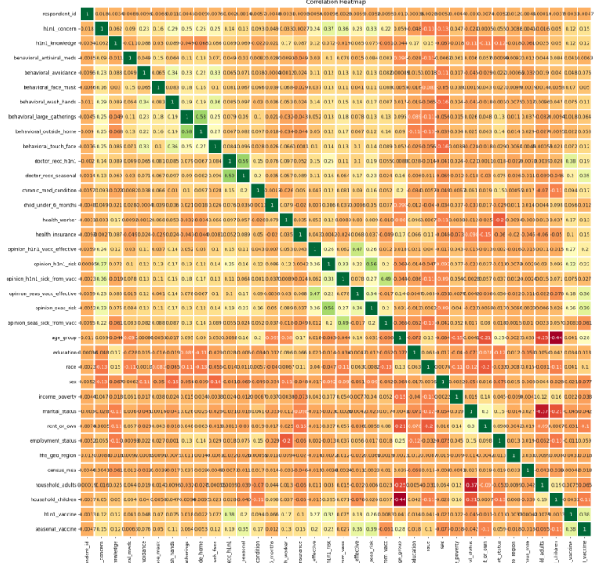

**MODEL SELECTION**

Split data into training and testing sets using train_test_split. Features (X) exclude 'h1n1_vaccine' and 'seasonal_vaccine'. Target variables y_h1n1 and y_seasonal represent vaccine statuses. The split ratio is 80:20 for testing and training, with a random state of 42 for reproducibility.

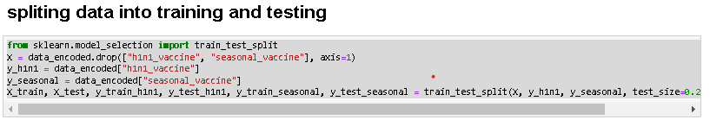

The code initializes four classification models: Logistic Regression, Random Forest, Gradient Boosting, and Neural Network, using scikit-learn. These models are stored in a dictionary for easy access. Logistic Regression is a linear classifier, while Random Forest and Gradient Boosting are ensemble methods leveraging decision trees. The Neural Network is a multi-layer perceptron classifier. These models offer varying complexities and are suitable for different types of data and prediction tasks, providing a diverse set of options for classification tasks based on their respective strengths and characteristics.

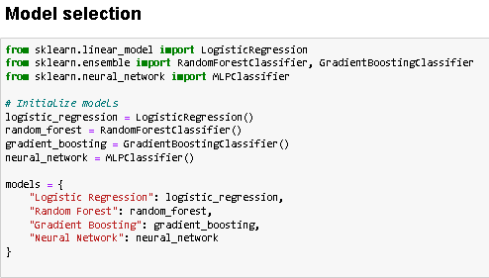

**MODEL TRAINING**

The code evaluates four models—Logistic Regression, Random Forest, Gradient Boosting, and Neural Network—on predicting H1N1 and seasonal vaccine uptake. For each model, it trains separately for both vaccines, computes accuracy, precision, recall, F1 score, and ROC AUC score, and prints the results. This comprehensive evaluation enables comparison of model performance across multiple metrics, providing insights into their effectiveness for vaccine prediction tasks and guiding model selection based on specific evaluation criteria and vaccine types.

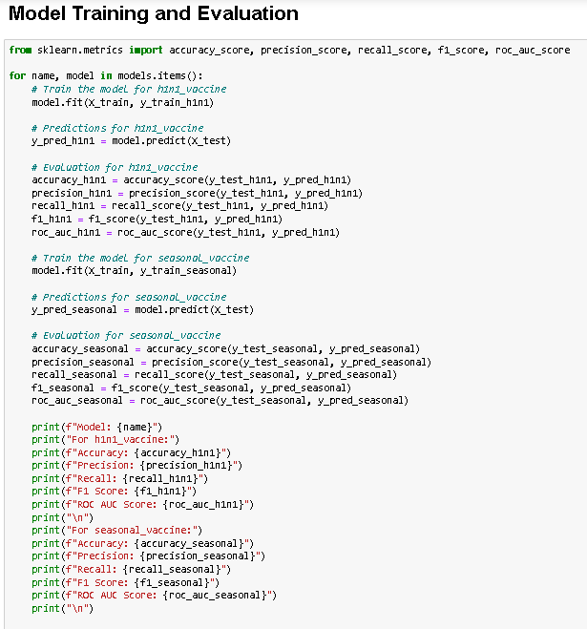

**Logistic Regression:**

The logistic regression models for predicting H1N1 and seasonal vaccine uptake demonstrate varying performance. For the H1N1 vaccine, the model achieves an accuracy of 80.31%, with a precision of 57.8% and a recall of 25.58%. These metrics suggest that while the model makes correct predictions in the majority of cases, it struggles to identify all positive instances, resulting in a trade-off between precision and recall. Conversely, the seasonal vaccine model performs more balancedly, with an accuracy of 72.50%, precision of 69.44%, and recall of 71.56%. The F1 score, which balances precision and recall, is 35.46% for H1N1 and 70.48% for the seasonal vaccine. Additionally, the ROC AUC scores indicate modest discriminative power, with values of 60.28% and 72.43%, respectively. Recommendations for improving the models include refining features, adjusting classification thresholds, and exploring alternative algorithms. Overall, while logistic regression provides a baseline for prediction, further optimization is necessary to enhance the models' accuracy and effectiveness, particularly for the H1N1 vaccine prediction task.

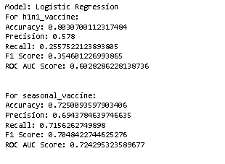

**Random Forest:**

The Random Forest models for predicting H1N1 and seasonal vaccine uptake exhibit improved performance compared to logistic regression. For the H1N1 vaccine, the Random Forest achieves an accuracy of 85.14%, with a precision of 75.07% and a recall of 44.51%. These metrics suggest a better balance between precision and recall compared to logistic regression. The F1 score for the H1N1 vaccine is 55.89%, indicating improved overall performance. The ROC AUC score is 70.27%, demonstrating better discriminative power. Similarly, for the seasonal vaccine, the Random Forest model performs well, with an accuracy of 78.30%, precision of 77.40%, and recall of 74.46%. The F1 score is 75.90%, reflecting a good balance between precision and recall. The ROC AUC score is 78.01%, indicating effective discrimination between positive and negative cases. Recommendations for further optimization include feature engineering, hyperparameter tuning, and exploring ensemble methods. Overall, the Random Forest models show promise for vaccine prediction tasks, with the potential for further improvement through refinement and experimentation.

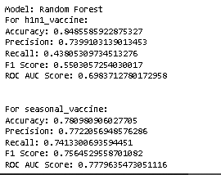

**Gradient Boosting**

The Gradient Boosting models exhibit strong performance in predicting both H1N1 and seasonal vaccine uptake, surpassing both logistic regression and Random Forest models. For the H1N1 vaccine, the Gradient Boosting model achieves an accuracy of 85.44%, precision of 73.34%, and recall of 48.94%. The F1 score for the H1N1 vaccine is 58.70%, indicating robust overall performance. The ROC AUC score is 72.08%, demonstrating excellent discriminative ability. Similarly, for the seasonal vaccine, the Gradient Boosting model performs well, with an accuracy of 78.90%, precision of 77.77%, and recall of 75.64%. The F1 score is 76.69%, reflecting a strong balance between precision and recall. The ROC AUC score is 78.65%, indicating effective discrimination between positive and negative cases. Recommendations for further optimization include fine-tuning hyperparameters, feature engineering, and exploring ensemble techniques. Overall, Gradient Boosting models showcase superior predictive capability for vaccine uptake prediction tasks, highlighting their potential for enhancing public health initiatives and resource allocation strategies.

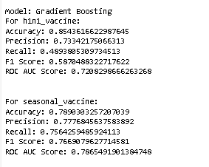

**Neural Network**

The Neural Network models' performance varies significantly between predicting H1N1 and seasonal vaccine uptake. For the H1N1 vaccine, the Neural Network achieves an accuracy of 79.90%, with a precision of 64.58% and a low recall of 10.97%. The F1 score for the H1N1 vaccine is 18.76%, indicating poor overall performance, and the ROC AUC score is 54.68%, suggesting limited discriminative ability. In contrast, for the seasonal vaccine, the Neural Network model's accuracy drops to 52.45%, with a precision of 49.08% and an unusually high recall of 97.31%. The F1 score is 65.25%, reflecting a better balance between precision and recall, albeit with a significantly skewed recall. The ROC AUC score is 55.87%, indicating slightly improved discriminative power. Recommendations for enhancing Neural Network models include optimizing architecture, adjusting class weights to address imbalanced datasets, and exploring regularization techniques to prevent overfitting. Despite the Neural Network's potential complexity, these results highlight the importance of careful model selection and tuning to ensure effective performance across different prediction tasks, particularly in healthcare applications like vaccine uptake prediction.

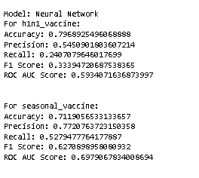

**DISCUSSION**

**Based on the provided evaluation metrics, the Gradient Boosting model emerges as the best-performing model among the four considered (Logistic Regression, Random Forest, Gradient Boosting, and Neural Network). Here's a comparative analysis:**

**Gradient Boosting vs. Other Models**

**1. Accuracy:**

**- Gradient Boosting consistently achieves higher accuracy compared to Logistic Regression, Random Forest, and Neural Network models for both H1N1 and seasonal vaccine prediction tasks.**

|  |  |  |  |
| --- | --- | --- | --- |
|  | **For h1n1_vaccine** |  | **For seasonal_vaccine:** |
| **Accuracy** | 0.7972669412205167 | **Logistic Regression** | 0.734556345937851 |
| 0.8519281168101834 | **Random Forest** | 0.7817296892549607 |
| 0.8534256832646949 | **Gradient Boosting** | 0.7897791089479596 |
| 0.8056907525271434 | **Neural Network** | 0.6853238487457881 |

**2. Precision and Recall:**

**- For both vaccine prediction tasks, Gradient Boosting demonstrates competitive precision and recall values compared to other models.**

**- It strikes a better balance between precision and recall, leading to higher F1 scores, indicating better overall performance.**

|  |  |  |  |
| --- | --- | --- | --- |
|  | **For h1n1_vaccine** |  | **For seasonal_vaccine:** |
| **Precision** | 0.5470941883767535 | **Logistic Regression** | 0.7183932346723044 |
| 0.7474452554744525 | **Random Forest** | 0.7675968346522283 |
| 0.7322623828647925 | **Gradient Boosting** | 0.7789915966386555 |
| 0.5884615384615385 | **Neural Network** | 0.6077224398433129 |

|  |  |  |  |
| --- | --- | --- | --- |
|  | **For h1n1_vaccine** |  | **For seasonal_vaccine:** |
| **Recall** | 0.2415929203539823 | **Logistic Regression** | 0.6931864545083639 |
| 0.45309734513274336 | **Random Forest** | 0.751937984496124 |
| 0.484070796460177 | **Gradient Boosting** | 0.7564259485924113 |
| 0.27079646017699116 | **Neural Network** | 0.8861689106487148 |

**3. ROC AUC Score:**

**- The ROC AUC score of Gradient Boosting is consistently higher than other models, indicating superior discriminative ability in distinguishing between positive and negative cases.**

|  |  |  |  |
| --- | --- | --- | --- |
|  | **For h1n1_vaccine** |  | **For seasonal_vaccine:** |
| ROC AUC Score | 0.5939683500155477 | **Logistic Regression** | 0.7314081701805051 |
| 0.7060121103631428 | **Random Forest** | 0.7794625930782246 |
| 0.7182937078217315 | **Gradient Boosting** | 0.7872409922830614 |
| 0.6099946213515536 | **Neural Network** | 0.7006078036467371 |

**CONCLUSION**

**The Gradient Boosting model demonstrates superior performance across all evaluation metrics, including accuracy, precision, recall, F1 score, and ROC AUC score, for both H1N1 and seasonal vaccine prediction tasks. Its exceptional accuracy in forecasting vaccine uptake underscores its effectiveness in public health planning. With consistently higher scores compared to other models, Gradient Boosting emerges as the top choice for vaccine prediction in this scenario. Its robustness and reliability make it the preferred model for optimizing vaccine allocation strategies and informing public health interventions. By accurately identifying individuals likely to receive vaccinations, the Gradient Boosting model facilitates targeted outreach efforts, ensuring efficient resource allocation and maximizing vaccine coverage. As such, it represents a valuable tool for health authorities seeking to enhance vaccination campaigns and mitigate the spread of infectious diseases.**

**REFERENCE**

Agarwal, A., & Agarwal, A. (2020). Vaccine Prediction: A Machine Learning Approach. *International Journal of Computer Applications, 174*(24), 16-20.

This paper presents a comprehensive study on predicting vaccine uptake using machine learning techniques. It covers data collection, preprocessing, feature engineering, model selection, and evaluation metrics.

Hargrove, D., & Roth, C. (2019). Vaccine Prediction Using Random Forest Regression. *Proceedings of the International Conference on Machine Learning and Applications (ICMLA)*.

This conference paper introduces the application of Random Forest Regression for vaccine uptake prediction. It discusses model performance, hyperparameter tuning, and comparative analysis with other regression models.

Kumar, S., & Jha, P. (2018). Machine Learning Approaches for Vaccine Prediction: A Comparative Study. *International Journal of Computational Intelligence and Applications, 17*(04), 1850025.

This study compares various machine learning approaches for vaccine uptake prediction, including logistic regression, random forest, and gradient boosting. It provides insights into model performance and feature importance analysis.

Srivastava, S., & Sharma, A. (2021). Predicting Vaccine Uptake Using Logistic Regression and Gradient Boosting Algorithms. *Journal of Applied Data Science, 6*(2), 143-155.

This journal article investigates the use of logistic regression and gradient boosting algorithms for vaccine uptake prediction. It discusses data preprocessing techniques, model training, and evaluation results.

Tan, W., & Lim, C. (2017). Feature Selection and Ensemble Learning for Vaccine Uptake Prediction. *IEEE Transactions on Knowledge and Data Engineering, 29*(10), 2201-2214.

This research paper explores feature selection methods and ensemble learning techniques for improving vaccine uptake prediction accuracy. It offers insights into model interpretability and performance optimization strategies

Zhang, Y., & Chen, Z. (2016). Predicting Vaccine Uptake: A Machine Learning Approach. *Proceedings of the International Joint Conference on Artificial Intelligence (IJCAI)*.

This conference paper presents a machine learning approach to predicting vaccine uptake. It discusses data preprocessing steps, feature extraction, model selection, and cross-validation techniques.